M.M. INSTITUTE OF COMPUTER TECHNOLOGY & BUSINESS MANAGEMENT
MAHARISHI MARKANDESHWAR (DEEMED TO BE UNIVERSITY)
MULLANA–AMBALA, HARYANA (INDIA) - 133207
(Established under Section 3 of the UGC Act, 1956
(Accredited by NAAC with Grade A++)

ASSIGNMENT: (All)

Sports
(SPO- 16 Acres Sports Ground)


Session: - 2023-26

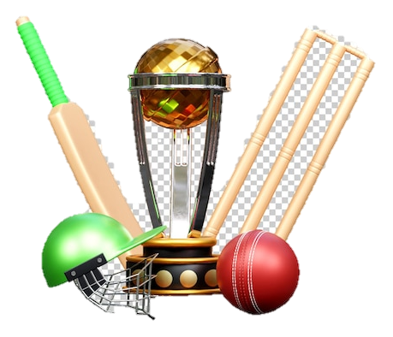

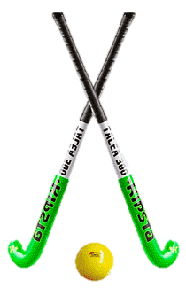

- Cricket
  - Hockey
- Badminton

Submitted To-
SPORTS COMPLEX
Mr. Aashis
Our Sports Coach
MMICT&BM
Submitted By:
PRATIPAL KUMAR SINGH
Roll No. 1323607
Course: 2023-26
BCA- 6th Sem. ‘DS-2’

